Solution

Module -7 : Containerization using Docker Part - II

1. Download your company’s website files from the given link

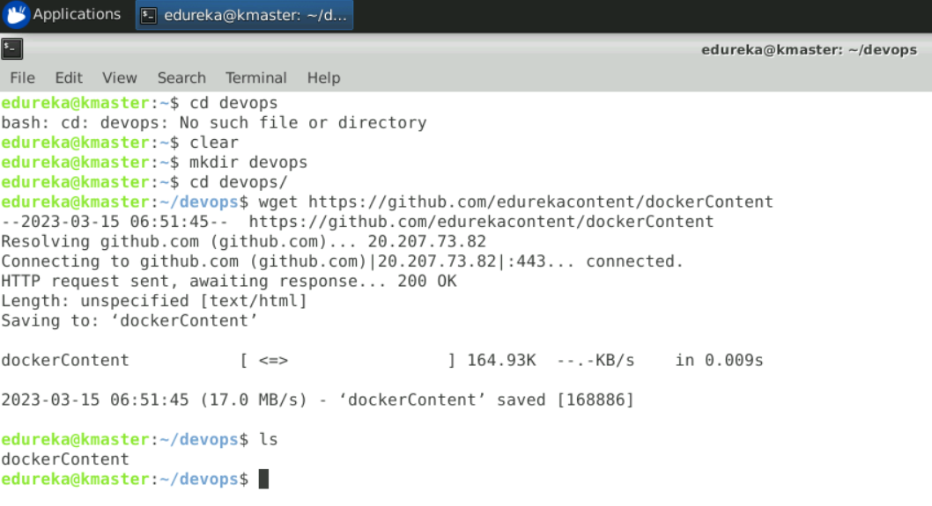

1. Write a docker file that will make your company’s website work out of the box with a web server.

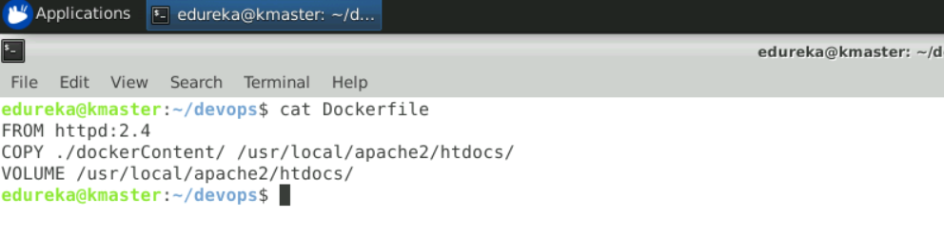

1. Make sure that you use volumes to store the actual data of the website outside of the container.

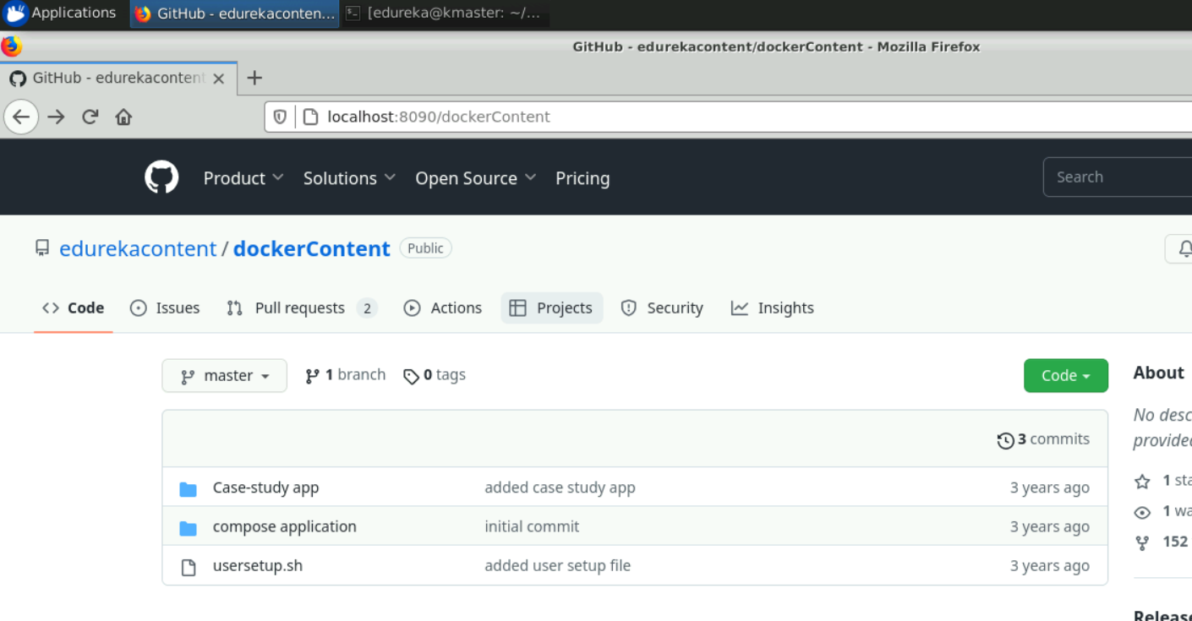

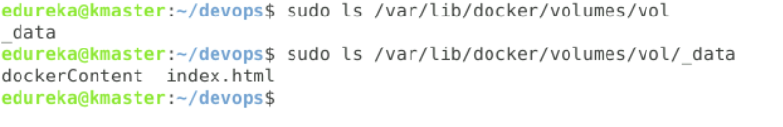

1. Push the docker image to your docker hub account.

$ docker image push username/devops_practice

1. 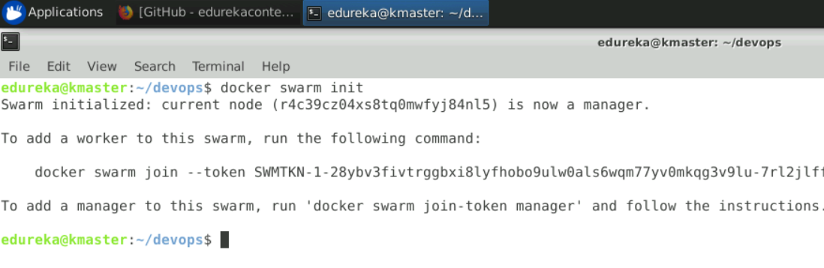Create a swarm cluster

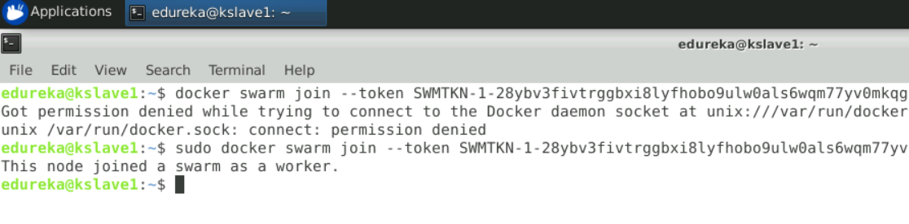

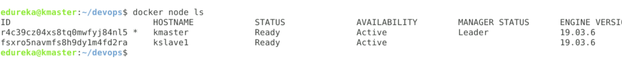

1. Deploy your firm’s website on the swarm cluster and expose port 80 to access the website.

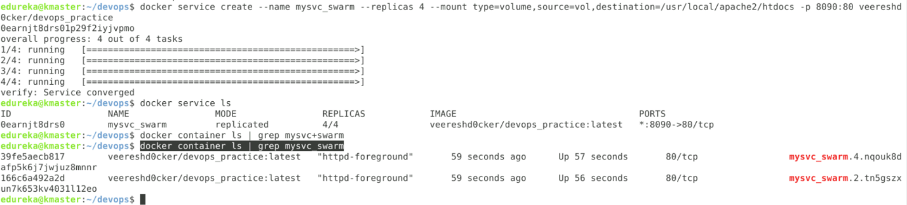



https://github.com/edurekacontent/dockerContent